GPS Tracking Application

Contents

Introduction 2

Features and Functionality 2

System Architecture 3

Screenshots 3

User Logon 3

Vehicle Tracking 4

Reports 7

Geo-Fencing 8

GPS Device Management 10

User Management 11

# Introduction

This is a GPS tracker web application that receives data from GPRS-connected GPS tracker devices and allows users on the system to track their vehicles.

The application has two major components – one, a listener component that receives data from GPS devices, and two, the web application itself. The application is architected this way to ensure future-proof compatibility with any GPS device that you might want to use with the application.

# Features and Functionality

Broadly, the application features are:

* Listener – a service that receives data from network-connected GPS devices, over either UDP or TCP
* Web – a web application that handles users, devices, tracking, and reporting
  + Users of the application have these features available to them:
    - Track vehicles in real time, assigned to them by an administrator
    - View historical data for vehicles assigned to them
    - Perform vehicle and device-specific functions, such are remotely disabling the engine
    - View reports
    - Create and use geo-fences – graphically defined geographic boundaries – so that the user is alerted when the vehicle passes into or out of a defined area
  + Administrators have these additional features available to them:
    - Track any vehicle in the system
    - View historical data for any vehicle
    - Add, edit, and delete vehicles or devices on the system
    - Add, edit, and delete users on the system
    - Assign administrative rights to other users
  + Alerts and notifications – users and administrators can setup alerts and notifications to be delivered over SMS text messages, and/or via email
  + Reports – reports can be viewed online, or saved to Excel and PDF formats
    - Reports can also be generated and emailed periodically to a specified email address

# System Architecture

The application is written using ASP.NET, specifically the ASP.NET MVC framework. It is designed to easily scale from a few dozen users to thousands of users and devices easily. The application includes scheduling for tasks like database backups and internal consistency checks.

The application is compatible with cloud-computing architectures, and has been tested to run on Amazon AWS and Microsoft Azure.

# Screenshots

## User Logon

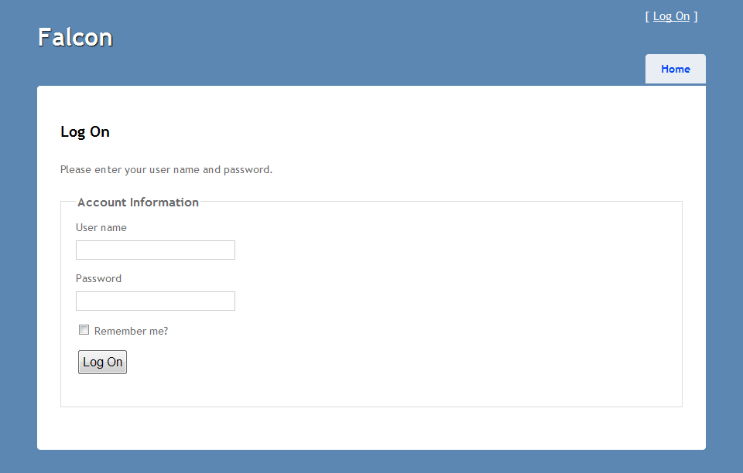

A simple user logon screen.

## Vehicle Tracking

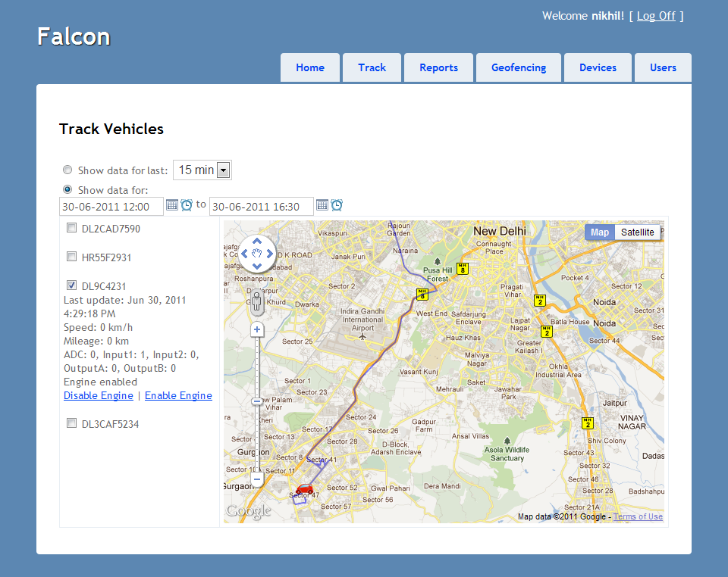

The tracking screen shows live data as well as historical data. The screen also allows users to disable the engine remotely, if the GPS device supports it.

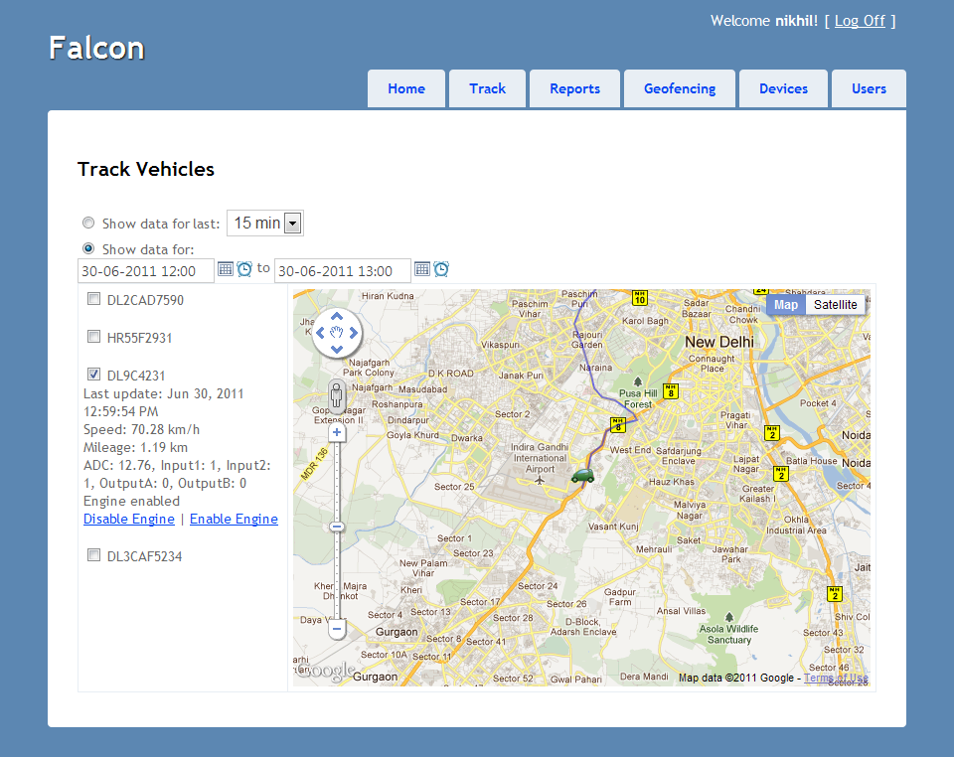

When the vehicle engine is on, the tracking display shows parameters like the current speed. The vehicle icon is green to indicate that the engine is on.

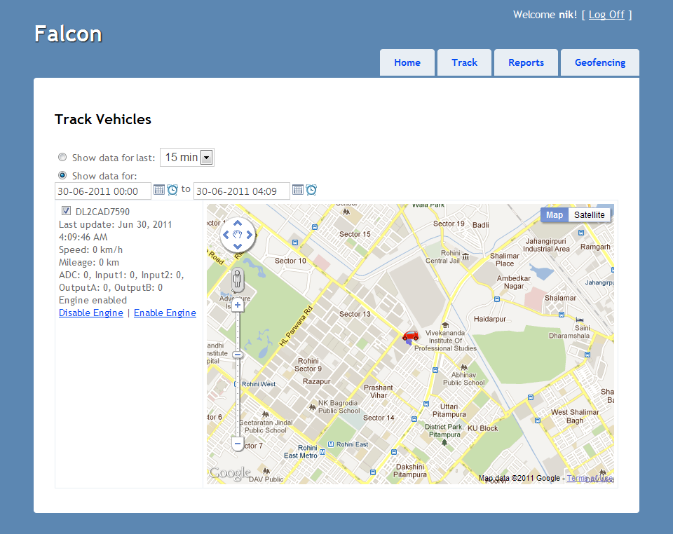

A user can only track the vehicles that are assigned to that user by an administrator.

## Reports

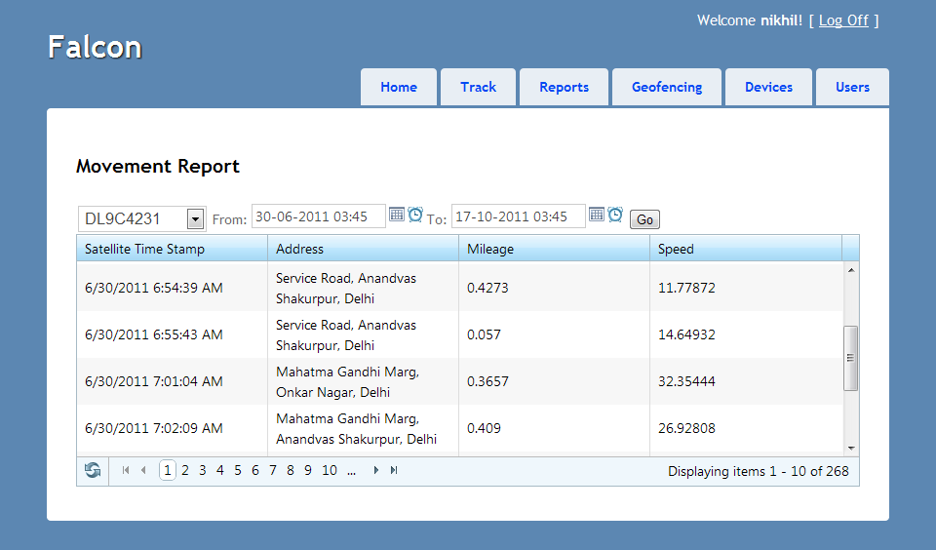

The movement report shows area names (reverse geo-coding) along with the speed and distance travelled.

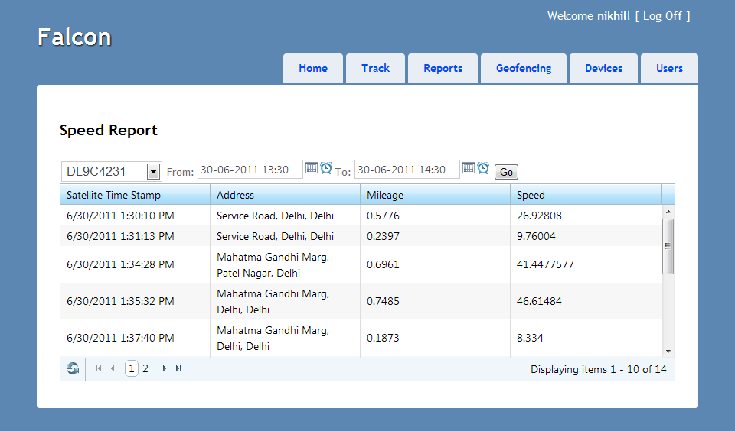

The speed report shows the top speed at various points of travel.

## Geo-Fencing

Geo-fencing allows a user to graphically define an area, and an alert is generated when selected vehicles leave or enter that area.

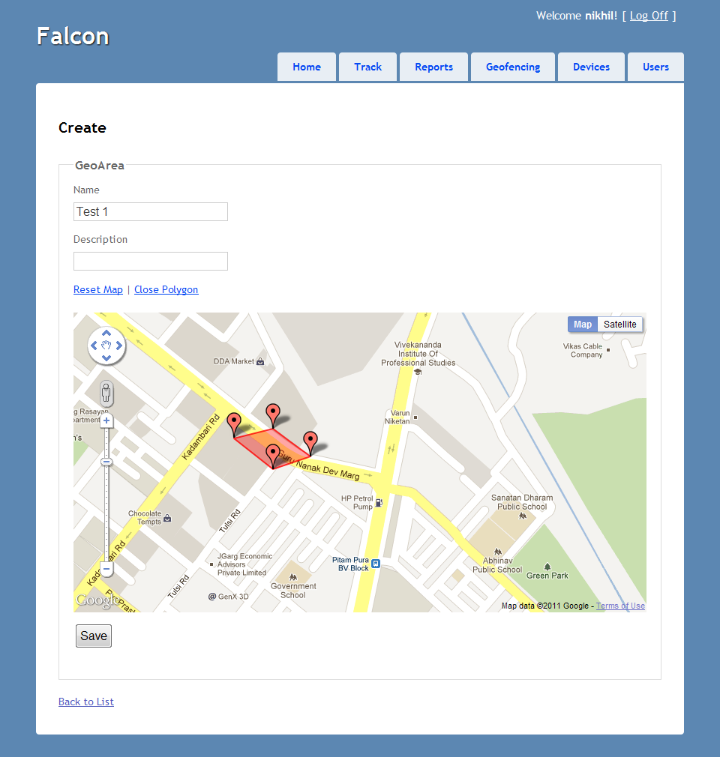

Defining a geo-fence is easy – just click on the vertex points on the map.

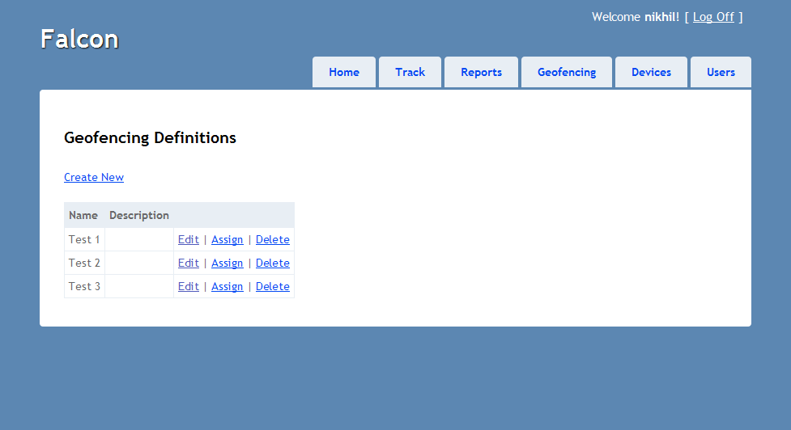

A list of geo-fencing definitions created by the user

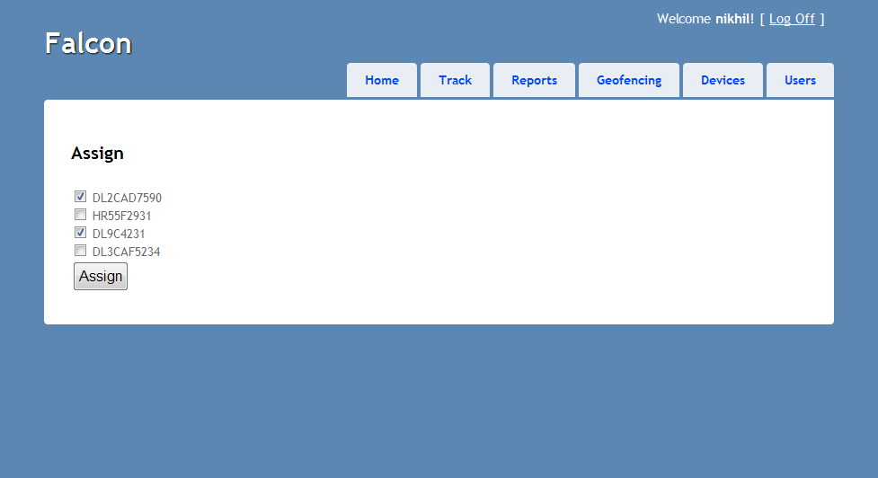

Assigning a geo-fence to vehicles

## GPS Device Management

Adding and editing GPS devices that report to the system

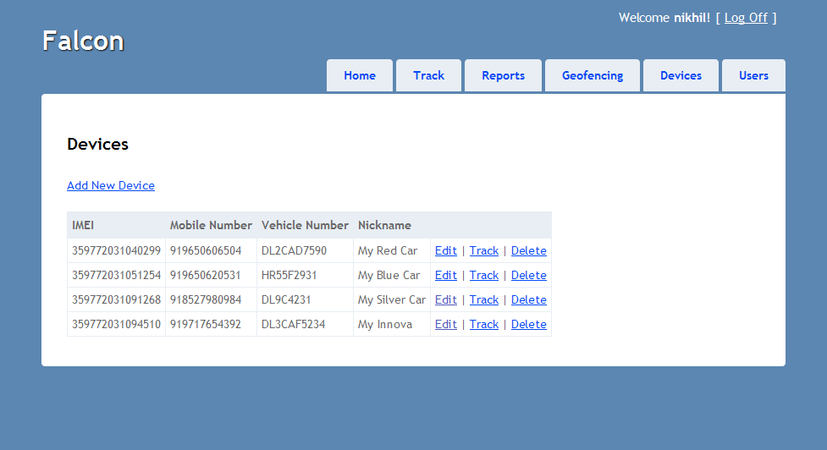

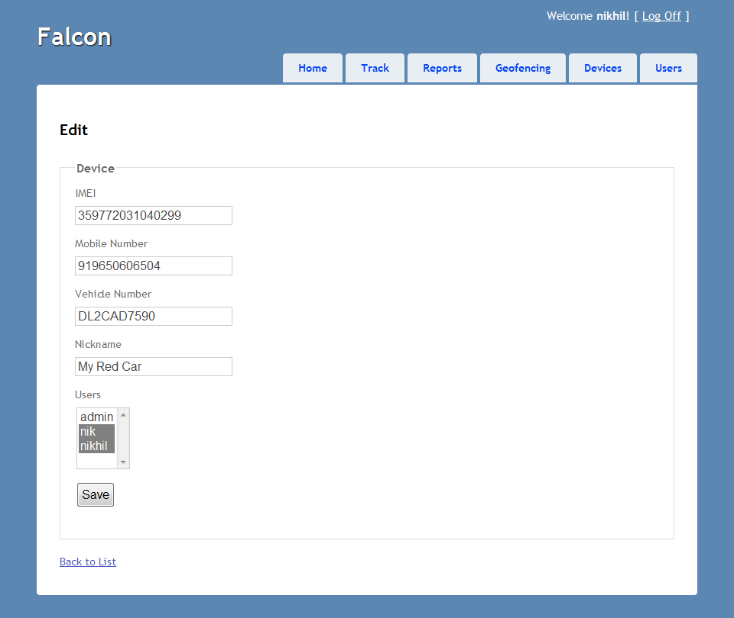

## User Management

Adding and editing users who have access to the system

